01.DISPLAY STUDENT INFORMATION USING CLASS AND OBJECTS
#include <iostream>
using namespace std;
class Student
{
public:
string name;
int roll;
float marks;
void getData()
{
cout << "Enter Student Name: ";
cin >> name;
cout << "Enter Roll Number: ";
cin >> roll;
cout << "Enter Marks: ";
cin >> marks;
}
void display()
{
cout << "\n--- Student Information ---\n";
cout << "Name: " << name << endl;
cout << "Roll Number: " << roll << endl;
cout << "Marks: " << marks << endl;
}
};
int main()
{
Student s;
s.getData();
s.display();
return 0;
}
OUTPUT:

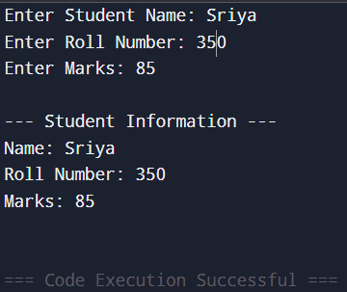

02. BOOK DETAILS (function defined outside class)
#include <iostream>
using namespace std;
class Book
{
public:
string title;
string author;
float price;
void getData();
void display();
};
void Book::getData()
{
cout << "Enter Book Title: ";
cin >> title;
cout << "Enter Author Name: ";
cin >> author;
cout << "Enter Book Price: ";
cin >> price;
}
void Book::display()
{
cout << "\n--- Book Details ---\n";
cout << "Title: " << title << endl;
cout << "Author: " << author << endl;
cout << "Price: " << price << endl;
}
int main()
{
Book b;
b.getData();
b.display();
return 0;
}
OUTPUT:

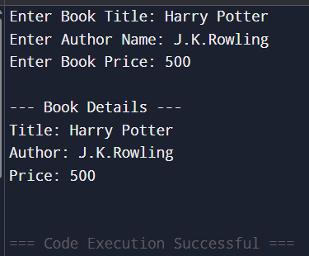

03.EMPLOYEE PAYSLIP USING CLASS&OBJECTS
#include <iostream>
using namespace std;
class Employee
{
public:
string name;
int id;
float basicPay;
float da, hra, gross, tax, net;
void getData();
void calculate();
void display();
};
void Employee::getData()
{
cout << "Enter Employee Name: ";
cin >> name;
cout << "Enter Employee ID: ";
cin >> id;
cout << "Enter Basic Pay: ";
cin >> basicPay;
}
void Employee::calculate()
{
da = basicPay * 0.70;
hra = basicPay * 0.10;
gross = basicPay + da + hra;
tax = gross * 0.20;
net = gross - tax;
}
void Employee::display()
{
cout << "\n--- Employee Payslip ---\n";
cout << "Name: " << name << endl;
cout << "ID: " << id << endl;
cout << "Basic Pay: " << basicPay << endl;
cout << "DA (70%): " << da << endl;
cout << "HRA (10%): " << hra << endl;
cout << "Gross Salary: " << gross << endl;
cout << "Tax (20%): " << tax << endl;
cout << "Net Salary: " << net << endl;
}
int main() {
Employee e;
e.getData();
e.calculate();
e.display();
return 0;
}

OUTPUT:

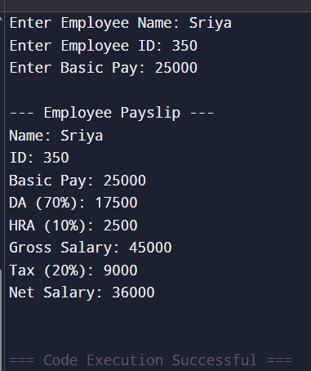

04.ELECTRICITY BILL
#include <iostream>
using namespace std;
class Electricity
{
public:
int units;
float bill;
void getData();
void calculate();
void display();
};
void Electricity::getData()
{
cout << "Enter Units Consumed: ";
cin >> units;
}
void Electricity::calculate()
{
if (units <= 100)
{
bill = units * 1.50;
}
else if (units <= 200)
{
bill = (100 * 1.50) + (units - 100) * 2.00;
}
else {
bill = (100 * 1.50) + (100 * 2.00) + (units - 200) * 3.00;
}
}
void Electricity::display()
{
cout << "\n--- Electricity Bill ---\n";
cout << "Units Consumed: " << units << endl;
cout << "Total Bill Amount: ₹" << bill << endl;
}
int main()
{
Electricity e;
e.getData();
e.calculate();
e.display();
return 0;
}

OUTPUT:
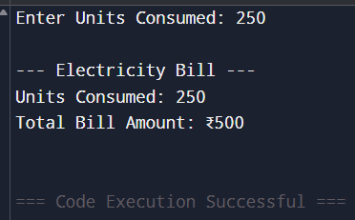

05.STUDENT INFORMATION FOR N STUDENTS
(Array of objects)
#include <iostream>
using namespace std;
class Student
{
public:
string name;
int roll;
float marks;
void getData();
void display();
};
void Student::getData()
{
cout << "Enter Name: ";
cin >> name;
cout << "Enter Roll Number: ";
cin >> roll;
cout << "Enter Marks: ";
cin >> marks;
}
void Student::display()
{
cout << "Name: " << name
<< " | Roll: " << roll
<< " | Marks: " << marks << endl;
}
int main()
{
int n;
cout << "Enter number of students: ";
cin >> n;
Student s[n];
cout << "\n--- Enter Student Details ---\n";
for (int i = 0; i < n; i++) {
cout << "\nStudent " << i + 1 << ":\n";
s[i].getData();
}
cout << "\n--- Student Information ---\n";
for (int i = 0; i < n; i++) {
s[i].display();
}
return 0;
}

OUTPUT:
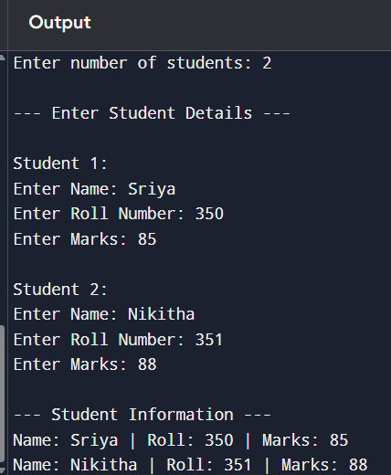

06. CONSTRUCTOR AND DESTRUCTOR
#include <iostream>
using namespace std;
class Demo
{
public:
Demo()
{
cout << "Constructor is called!" << endl;
}
~Demo()
{
cout << "Destructor is called!" << endl;
}
};
int main()
{
cout << "Creating object..." << endl;
Demo obj;
cout << "Program is ending..." << endl;
return 0;
}

OUTPUT:
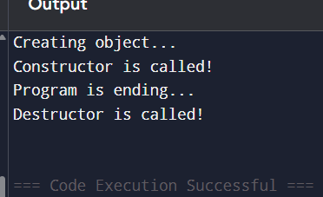

07. CONSTRUCTOR OVERLOADING
#include <iostream>
using namespace std;
class Demo
{
public:
int a, b;
Demo()
{
a = 0;
b = 0;
cout << "Default Constructor Called" << endl;
}
Demo(int x)
{
a = x;
b = 0;
cout << "Constructor with 1 parameter Called" << endl;
}
Demo(int x, int y)
{
a = x;
b = y;
cout << "Constructor with 2 parameters Called" << endl;
}

void display()
{
cout << "a = " << a << ", b = " << b << endl;
}
};
int main()
{
Demo d1;
d1.display();
Demo d2(10);
d2.display();
Demo d3(20, 30);
d3.display();
return 0;
}
OUTPUT:
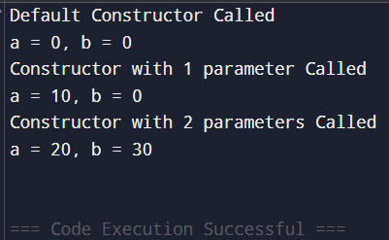

08. OBJECT AS FUNCTION ARGUMENT
#include <iostream>
using namespace std;
class Number
{
public:
int value;
void getData(string msg)
{
cout << msg;
cin >> value;
}
};
void compare(Number n1, Number n2)
{
cout << "\nComparing Numbers...\n";
if (n1.value > n2.value)
cout << n1.value << " is greater\n";
else if (n2.value > n1.value)
cout << n2.value << " is greater\n";
else
cout << "Both numbers are equal\n";
}
int main() {
Number a, b;

a.getData("Enter first number: ");
b.getData("Enter second number: ");
compare(a, b);
return 0;
}
OUTPUT:
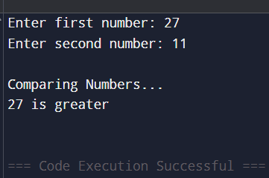

09.FUNCTION OVERLOADING
#include <iostream>
using namespace std;
class Overload
{
public:
void display()
{
cout << "Display with no parameters" << endl;
}
void display(int x)
{
cout << "Display with one integer: " << x << endl;
}
void display(int x, float y)
{
cout << "Display with two parameters: ";
cout << "x = " << x << ", y = " << y << endl;
}
};
int main()
{
Overload obj;
obj.display();
obj.display(10);
obj.display(20, 3.5f);

return 0;
}
OUTPUT:
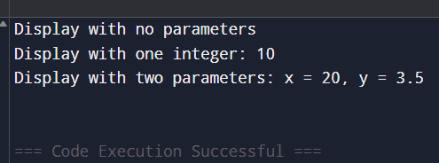

10. INLINE FUNCTION
#include <iostream>
using namespace std;
inline int add(int a, int b)
{
return a + b;
}
inline int subtract(int a, int b)
{
return a - b;
}
inline int multiply(int a, int b)
{
return a * b;
}
inline float divide(float a, float b)
{
return a / b;
}
inline int square(int x)
{
return x * x;
}
int main()
{
int x, y;
cout << "Enter first number: ";
cin >> x;
cout << "Enter second number: ";
cin >> y;
cout << "\n--- Inline Function Results ---\n";
cout << "Addition: " << add(x, y) << endl;
cout << "Subtraction: " << subtract(x, y) << endl;
cout << "Multiplication: " << multiply(x, y) << endl;
if (y != 0)
cout << "Division: " << divide(x, y) << endl;
else
cout << "Division: Not possible (div by 0)" << endl;
cout << "Square of first number: " << square(x) << endl;
cout << "Square of second number: " << square(y) << endl;
return 0;
}

OUTPUT:
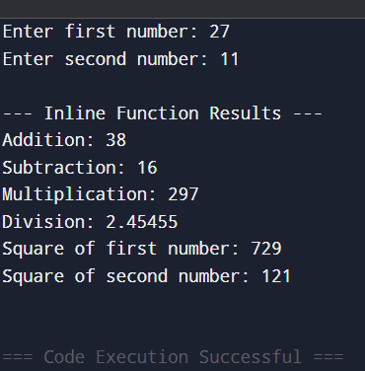

11. MANIPULATORS
#include <iostream>
#include <iomanip>
using namespace std;
int main()
{
int a = 25, b = 1234;
float x = 45.6789;
cout << "--- Demonstrating Manipulators ---" << endl;
cout << "Using setw(): " << endl;
cout << setw(5) << a << endl;
cout << setw(5) << b << endl;
cout << "\nUsing setprecision() and fixed:" << endl;
cout << fixed << setprecision(2);
cout << "Value of x = " << x << endl;
cout << "\nUsing showpoint:" << endl;
cout << showpoint << 45.0 << endl;
cout << "\nUsing endl:" << endl;
cout << "This is line 1" << endl;
cout << "This is line 2" << endl;
return 0;
}

OUTPUT:
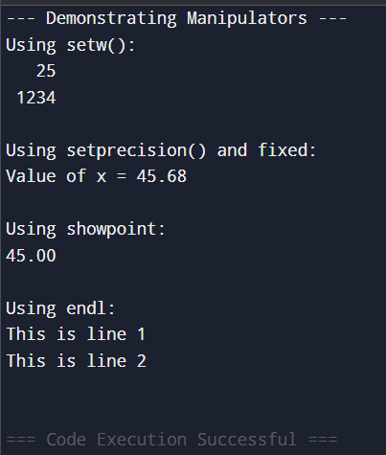

12. STATIC DATA MEMBER AND STATIC DATA FUNCTION
#include <iostream>
using namespace std;
class Student
{
private:
int roll;
static int count;
public:
void getData(int r)
{
roll = r;
count++;
}
void display()
{
cout << "Roll Number: " << roll << endl;
}
static void showCount()
{
cout << "Total Students = " << count << endl;
}
};
int Student::count = 0;
int main()
{
Student s1, s2, s3;
s1.getData(101);
s2.getData(102);
s3.getData(103);
s1.display();
s2.display();
s3.display();
Student::showCount();
return 0;
}
OUTPUT:
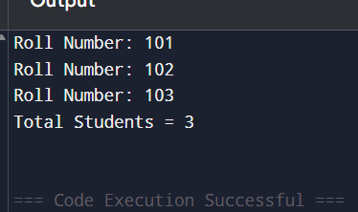

13.UNARY OPERATOR OVERLOADING
#include <iostream>
using namespace std;
class Number
{
private:
int value;
public:
Number(int v)
{
value = v;
}
void operator++()
{
value = value + 1;
}
void display()
{
cout << "Value = " << value << endl;
}
};
int main()
{
Number n1(5);
cout << "Before increment:" << endl;
n1.display();
++n1;
cout << "After increment:" << endl;
n1.display();
return 0;
}
OUTPUT:
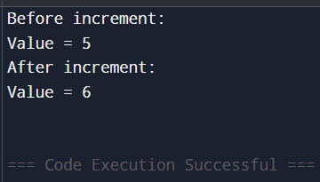

14.FRIEND FUNCTION
#include <iostream>
using namespace std;
class Sample
{
private:
int a, b;
public:
Sample(int x, int y)
{
a = x;
b = y;
}
friend int add(Sample s);
};
int add(Sample s)
{
return s.a + s.b;
}
int main()
{
Sample obj(10, 20);
cout << "Sum = " << add(obj) << endl;

return 0;
}
OUTPUT:
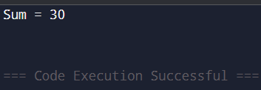

15.BINARY OPERATOR OVERLOADING
#include <iostream>
using namespace std;
class Number
{
private:
int value;
public:
Number(int v = 0)
{
value = v;
}
Number operator+(Number obj)
{
Number temp;
temp.value = value + obj.value;
return temp;
}
void display()
{
cout << "Value = " << value << endl;
}
};
int main()
{
Number n1(10);
Number n2(20);
Number n3 = n1 + n2;
cout << "After addition:" << endl;
n3.display();
return 0;
}
OUTPUT:
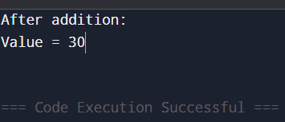

#include <iostream>
#include <cstring>
using namespace std;
class MyString
{
char str[50];
public:
MyString() { str[0] = '\0'; }
MyString(const char s[]) {
strcpy(str, s);
}

// Overloading + operator for string concatenation
MyString operator+(MyString s) {
MyString temp;
strcpy(temp.str, str);
strcat(temp.str, s.str);
return temp;
}

void display() {
cout << str << endl;
}
};

int main() {
MyString s1("Hello ");
MyString s2("World!");

MyString s3 = s1 + s2; // Calls operator+

cout << "Concatenated String: ";
s3.display();

return 0;
}

